Services for next week:
Hampton-in-Arden

Thursday 30th April
10am Communion

Sunday 3rd May
8.15am Common Worship
11am All-Age Service
6.30pm Healing Communion

Bickenhill

Sunday 3rd May
11am Morning Prayer

Barston

Sunday 3rd May
9.45 Prayer Time
10.30am All-Age Service taken by Linda and Martin.

Readings for next week:
Acts 7 55-end; John 14.1-14

We pray for: Bob Middleton, Judy Middleton, David Mort, Ann Hall, Tony Worthington, Mona Cardall, Dot Barton, Richard Herne, David Vickers, Vickey Cardwell and Chris Cluley. Paul Pilkington-Birch, Richard Mitchell, Roger Abrahams, Morris Dobbie, Doreen Morris, Doug Holdom, Robin Mortimore, Michelle Cluley, Keith Ward, Jenny Miller, Rick Smallwood, Graham Stidworthy, Gwen Eley and Jenny Miller.
We also pray for the families of those who have died; Eileen Taylor, Roger Harrison, Neil Jones, Gerald Boston, John Isham, Joan Wilson, David Moore and Pauline Booker. If you would like people to be prayed for do let us know at office@hamptoninardenchurch.org.uk
Please recycle this pew slip.
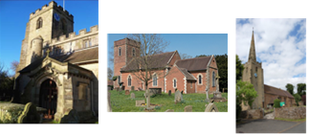

Hampton. Barston. Bickenhill.

Three Churches Together.

Sharing God’s Love, Growing Faith and Worshipping Together.

26th April 2026- 4th Sunday of Easter
Acts 2 42-end; John 10.1-10

Thought for the week
In John 10:1-15, Jesus uses the metaphors of the sheepfold, the gate, and the Good Shepherd to illustrate His identity and His mission. He begins by contrasting the true shepherd with "thieves and robbers" who enter the sheepfold by climbing over walls rather than through the gate. The true shepherd is recognized by the gatekeeper and, crucially, by the sheep themselves, who know His voice and follow Him.
Jesus explicitly identifies Himself as both the Gate and the Good Shepherd. As the Gate, He is the only legitimate way for the sheep to enter into safety, find pasture, and experience "abundant life". As the Good Shepherd, His role is defined by sacrificial love and intimate knowledge. He knows each of His sheep by name, and they in turn know Him.
The passage culminates in a contrast between the Good Shepherd and a "hired hand." While a hired worker flees when danger, such as a wolf, approaches, the Good Shepherd does not abandon the flock. Instead, He willingly lays down His life for the sheep to ensure their protection and salvation. CT.
Collect
Risen Christ,
faithful shepherd of your Father’s sheep:
teach us to hear your voice
and to follow your command,
that all your people may be gathered into one flock,
to the glory of God the Father.
Please note that Rev. Stuart is on annual leave until Thursday 30th April. For any queries contact the church office on 01675 442769 or office@hamptoninardenchurch.org.uk
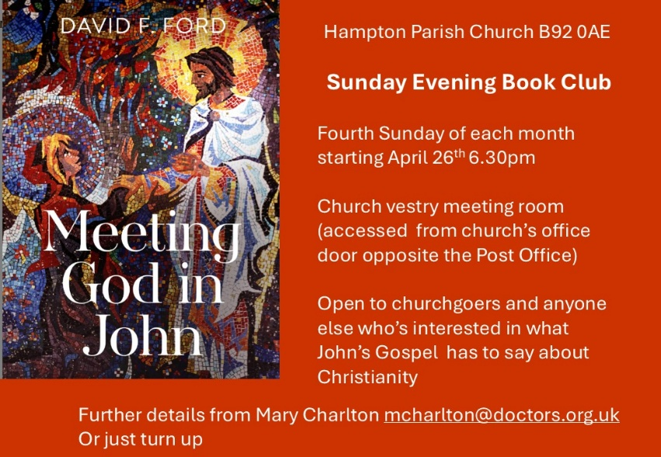

Hampton
- Thank you to everyone who brought in flowers for our flower festival to celebrate April’s birthday last week. The church looked beautiful, and it was a fitting tribute to someone who has spent so much time and effort over the years making the church look so wonderful for us all to enjoy.
- Tonight is our Sunday Evening Book Group: Every 4th Sunday, we meet in the vestry at 6.30pm to delve deeper into our faith and scripture in friendly and supportive conversation. After Easter we shall be basing our discussion on the book "Meeting God in John" by David Ford. New participants and occasional attendees are always welcome. You don't need to sign up in advance but if you'd like a copy of the book (£9.30) please let Mary know mcharlton@doctors.org.uk or source one from your favourite book supplier! If the price is a barrier to coming, let Mary know and we'll get round that.
- Tea and Toast next meeting Friday 8th May at 9-10.15am in the church hall.
- Help needed for our Churches Together Ascension Day service on 14th May. Mary Charlton would be very grateful for any help in providing refreshments after the choir rehearsal and before the service. Please contact the church office or Mary at mcharlton@doctors.org.uk to offer help. There will be fizz for all after the service!

Barston
- Today we welcome back Alan and Sarah . We look forward to hearing Alan preach once again. He is such a gifted Bible teacher and brings the words on the page alive and makes them relevant to us today.
- Next Sunday, apart from All-Age Service we have monthly Bring and Share Lunch. Always a good time of fellowship not to mention delicious food.
- Big Breakfast 9th May (NB this is second Saturday due to a Bank Holiday on 2nd May).
- Date for Diary – St SWITHIN’S WEEKEND. July 11th & 12th. Bishop Esther will be joining us for the Outdoor Service in the garden on the Sunday and for the lunch afterwards. Put the date in your diary and pray about who you could invite. More details to follow in May. We will be needing lots of help to make the weekend happen.
- Please continue to pray for Graham and Jenny as they recover from their recent knee replacements and for those looking after them. For Martin recovering from a hernia operation this week. For Doreen and Robin in their daily challenges with Parkinson’s and for Gordon and Sue as they care for them. For Val with memory issues and for others here today who have concerns for family members. We pray that you will lean into our loving Heavenly Father who is alongside you at all times.
