Services for next week:
Hampton-in-Arden

Thursday 15th October
10am Communion (SR/MC)

Sunday 18th October
8.15am Eucharis (Tony Rindl, Area Dean)
11am Eucharist (SR) with Alison Dimes preaching
6.30pm Evensong (MC)

Bickenhill

Sunday 18th October
11am Matins

Barston

Sunday 18th October
9.45 Prayer Time
10.30am Morning Prayer

Readings for next week:
1 Thessalonians 1.1-10; Matthew 22. 15-22

We pray for: Judy Middleton, David Mort, Ann Hall, Tony Worthington, Mona Cardall, Dot Barton, Richard Herne, David Vickers, Vickey Cardwell, Chris and Michelle Cluley, Ann Hall, Kevin, Michele Garrison, Owen Cooling and Rev. Stuart Dimes. Paul Pilkington-Birch, Roger Abrahams, Morris Dobbie, Doreen Morris, Robin Mortimore, Keith Ward, Rick Smallwood, Gwen Eley, Pauline Tutchings, Trixie Harman and Peter Smith.

We also pray for the families of those who have died; Anne Oliver-Jones, Angela Jones, Janet Griffiths, Barbara Waring, Dawn Byrne, Audrey Clayton Pearce, Richard Mitchell, Malcolm Baldwin and the McDonald family. If you would like people to be prayed for do let us know office@hamptoninardenchurch.org.uk

Please recycle this pew slip.

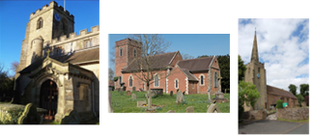

Hampton. Barston. Bickenhill.

Three Churches Together.

Sharing God’s Love, Growing Faith and Worshipping Together.

11th October 2026- Trinity 19

Philippians 4.1-9; Matthew 22. 1-14

Thought for the week

“The kingdom of heaven is like a king who prepared a wedding banquet for his son” (Matt 22:1). That is essentially the story of the Bible, which begins with the marriage of the man and the woman in the Garden (Gen 2), and ends with the marriage of Christ to his bride, the church (Rev 21-22). At the heart of the story God sends the bridegroom to invite his people to the marriage feast.
The closest most of us get to a royal wedding is to watch it on TV. But for this, the wedding to beat all weddings, you are personally invited. So, RSVP!
And remember that to take your place at the feast you need to be properly dressed, or you’ll be chucked out. So, clothe yourselves with compassion, kindness, humility, gentleness and patience, all bound together with love (Col 3:12-14)
Alan Black

Collect

Faithful Lord,
whose steadfast love never ceases
and whose mercies never come to an end:
grant us the grace to trust you
and to receive the gifts of your love,
new every morning,
in Jesus Christ our Lord.

Hampton

- Many thanks to those who contributed items during the Harvest service, these were collected by Community Essentials Foodbank in Olton. They were extremely grateful as their shelves were almost bare. Children from George Fentham School also made a huge donation during their Harvest Service in church. Thank you so much to Mary Charlton for stepping in and leading this lovely service and to all those who helped to make things to run so smoothly.
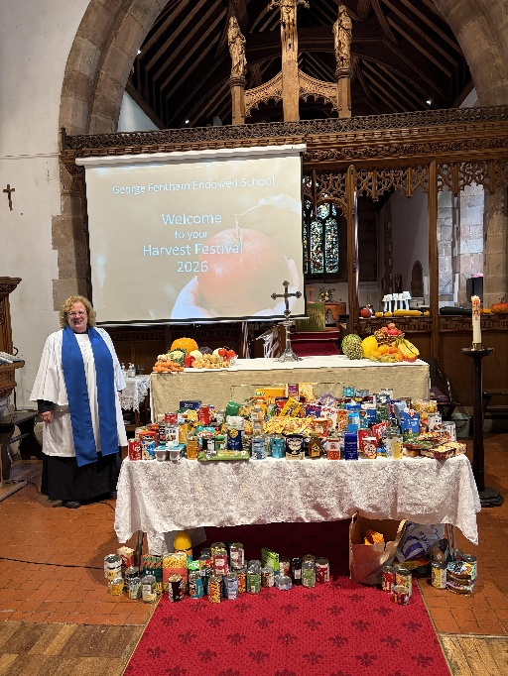

- Friday 16th October Tea and Toast Stay and Play group in the church hall, 9-10.15am. All welcome.
- Saturday 17th October Ladies’ Breakfast in the church hall at 9am.
- Saturday 31st October Children’s Light Party in the hall and church, 3pm. Please spread the word to local friends and family and do let Jess know if you are willing and able to help in any way.
- Sunday 1st November All Souls’ Service 6.30pm in church. Please add names to the list in church or e-mail them to office@hamptoninardenchurch.org.uk
- Christmas Fair Saturday December 12th in the Fentham Hall 10-3pm.



Barston
- Thanks to all those who made our Harvest Sunday so special, especially Rachael and all those who helped in the service which will long linger in memories. We know that all the produce that Jean collected on Monday will be turned into meals for people in Kingshurst.
- Monday 12th Open the Book rehearsal for the team for this half term’s assemblies. These are Tuesday 13th at 9.10am and Wednesday 14th 10.10am at Balsall Common. Please pray for this opportunity to tell Bible stories through drama in our local primary schools.
- Last week Hampton Beavers and Cubs made a visit to our churchyard to look for bats. They were successful. There is some information in the church relating to their visit. Thanks to Gill and Rachael for making this trip possible and successful.
- Christmas Fayre November 14th in St. Swithin’s House, 10am-1pm.

