Services for next week:
Hampton-in-Arden

Thursday 1st October
10am Communion

Sunday 4th October
8.15am Communion (SM)
11am All Age Service with Suzy Pearson
6.30pm NO SERVICE

Bickenhill

Sunday 4th October
11am Morning Prayer

Barston

Sunday 4th October
9.45 Prayer Time
10.30am Harvest

Readings for next week:
Philippians 3.4-14; Matthew 21. 33-end

We pray for: Judy Middleton, David Mort, Ann Hall, Tony Worthington, Mona Cardall, Dot Barton, Richard Herne, David Vickers, Vickey Cardwell, Chris and Michelle Cluley, Ann Hall, Kevin and Michele Garrison. Paul Pilkington-Birch, Roger Abrahams, Morris Dobbie, Doreen Morris, Robin Mortimore, Keith Ward, Rick Smallwood, Gwen Eley, Gary Wood, Pauline Tutchings, Trixie Harman and Peter Smith.
We also pray for the families of those who have died; Anne Oliver-Jones, Angela Jones, Janet Griffiths, Barbara Waring, Dawn Byrne, Audrey Clayton Pearce, Richard Mitchell, Malcolm Baldwin and the McDonald family. If you would like people to be prayed for do let us know office@hamptoninardenchurch.org.uk

Please recycle this pew slip.

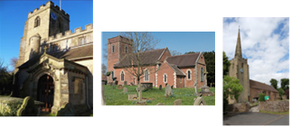

Hampton. Barston. Bickenhill.

Three Churches Together.

Sharing God’s Love, Growing Faith and Worshipping Together.

27th September 2026- Trinity 17

Deuteronomy 28.1-14; Luke 17. 11-19

Thought for the week

Both readings remind us of God’s blessings and our response to them. In Deuteronomy,
God promises blessings to those who listen to him and follow his ways. In Luke, 10 lepers are healed by Jesus, but only one returns to say thank you. It is easy to ask God for help, but do we remember to thank him when our prayers are answered?
The Samaritan recognised that his healing was a gift from God, and he returned to Jesus in gratitude.
Today, let us remember not to take God’s blessings for granted. Whatever our
circumstances, there is always something we can thank God for.
Let us be people who not only receive God’s blessings, but who remember to say “Thank
you”, Lord. C.T.

Collect

Gracious God,
you call us to fullness of life:
deliver us from unbelief
and banish our anxieties
with the liberating love of Jesus Christ our Lord.

Please be aware Rev. Stuart will be having a hip replacement on Tuesday 29th September and will be away from work for around six weeks.

Hampton

- Congratulations from the whole church family to Elizabeth and Kun on the safe arrival of their daughter, Poppy, on Tuesday.
- PCC meeting Monday 28th September at 7.30pm in the church office.
- Friday 2nd October 9-10.15am Tea and Toast Stay and Play in the church hall.
- Harvest supper next Friday 2nd October at 6.30pm. Please sign the list at the back of church or contact the church office by Tuesday. All are very welcome!
- Christmas Fair Saturday December 12th in the Fentham Hall 10-3pm.
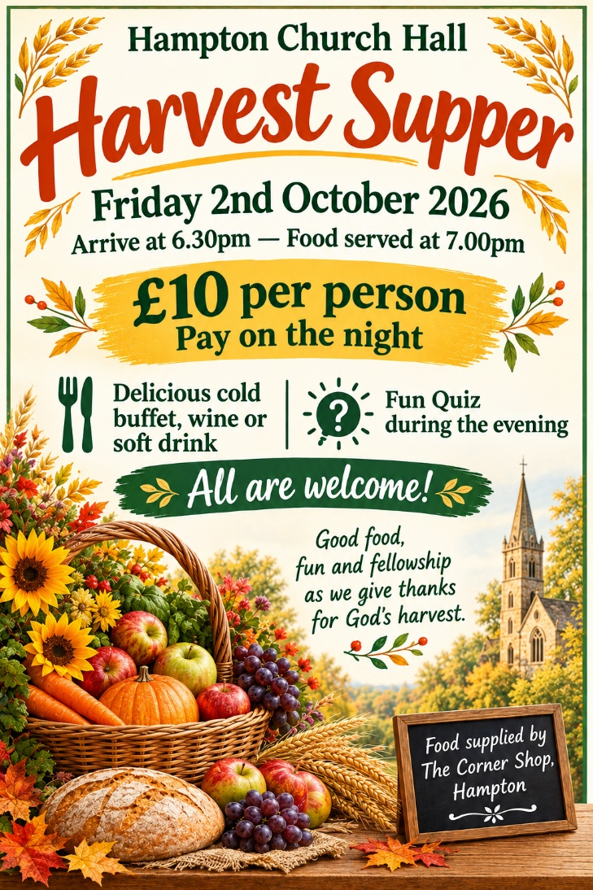

Barston
- Thank you to Sue Ashton who will be presiding at communion today and to Alan Black who be preaching. We are really grateful to you both that you can join us once again.
- October 2nd from 9am decorating the church for harvest. Please come if you can, we will be in church until late morning. Fresh produce, if possible, but tins are also welcome. Food will once again go to a local charity in Kingshurst. Jean will be here in our service to talk about her work. If you cannot help but would like to give produce, please let us know and we can collect. Alternatively, you can donate, and we can give that to Jean, who will be heading up the team to provide the meals.
- Also, next week, we welcome to our service a speaker from A Rocha, the only Christian environmental charity. We will be having a special offering to support this vital work as well. Family lunch will follow the service. Our speaker will be staying so it’s a good opportunity to chat to him and find out more.
- Big Breakfast will be on 10th October.
- Christmas Fayre November 14th in St. Swithin’s House, 10am-1pm.

Bickenhill
- PCC meeting today after the service.
