Services for next week:
Hampton-in-Arden

Thursday 12th March
10am Holy Communion

Sunday 15th March
8.15am Common Worship
11am Mothering Sunday Family Eucharist with JAM children’s group.
6.30pm Evensong

Bickenhill

Sunday 15th March
11am Matins

Barston

Sunday 15th March
9.45 Prayer Time
10.30am Mothering Sunday worship (we are delighted to welcome Alison Dimes who will be preaching).

Readings for next week:
1 Samuel 1. 20-end, Luke 2. 33-35.

We pray for: Bob Middleton, Judy Middleton, David Mort, Mike Beasley, Ann Hall, Tony Worthington, Angela Jones, Mona Cardall, Dot Barton, Richard Herne, David Vickers, Vickey Cardwell and Chris Cluley. Paul Pilkington-Birch, Val Sharp, Richard Mitchell, Roger Abrahams, Morris Dobbie, Doreen Morris, Doug Holdom, Rev. Stephen Mayes, Robin Mortimore, Michelle Cluley, Keith Ward, Rick Smallwood, Gwen Eley, Gary Wood and Gloria Stidworthy.
We also pray for the families of those who have died; Betty Clarke, Alan Bloomfield, Wendy Raby, Dr. John Hodgson, Eileen Taylor, Roger Harrison, Neil Jones, Gerald Boston, John Isham, Joan Wilson and David Moore. If you would like people to be prayed for do let us know at office@hamptoninardenchurch.org.uk

Please recycle this pew slip.

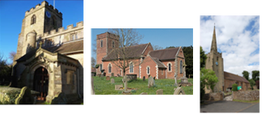

Hampton. Barston. Bickenhill.

Three Churches Together.

Sharing God’s Love, Growing Faith and Worshipping Together.

8th March 2026- 3rd Sunday of Lent
Romans 5. 1-11, John 4. 5-42.

Thought for the week

Unexpected conversation
John 4 5-42
Working out the first words to say to a stranger can be hard. Often, we choose to
say nothing, avoid eye contact and move on. But sometimes, if we can find the right
words, an unexpected conversation changes us, as it did for the woman at the well.
She approaches Jesus, he looks up and asks for a drink. A conversation begins that
changed her life for ever, she met with God.
As we think about the week ahead, I wonder what ‘wells’ God might lead us to, and
what unexpected conversations we might have. Wherever we end up, in having
these conversations may we discover in them the well of life-giving water which
changes us and encourages others to come and see.
S.D.

Collect

Eternal God,
give us insight
to discern your will for us,
to give up what harms us,
and to seek the perfection we are promised
in Jesus Christ our Lord.

Hampton
- PCC meeting Wednesday11th March 7.30pm in the vestry.
- Thursday 12th March Lent Course after the Communion service at 10am. Meet 10.45 in the church hall for drinks to start at 11am. This week we consider thanksgiving in prayer.
- Tea and Toast will meet on Friday 13th March at 9am in the church hall.
- Saturday 14th March wedding of Charles and Sophia.
- Saturday 21st Ladies’ Breakfast in the church hall. All welcome.
- Lent Lunch at 12.30pm in the church hall on 22nd March. See the sign-up list on the clipboard in church. Please indicate any allergies or dietary requirements.
- Our church APCM will be in church at 7pm on March 26th. To be elected or to vote you need to be on the electoral roll. We have spaces for new PCC members, Churchwarden(s) and Deanery Synod. Forms on the red board in church.


Barston
- Lent Course Wednesday 11th March in St. Swithin’s House at 2pm. Refreshments at 3pm. Week four of the course. It’s proving to be a refreshing, reflective course. Not too late to come as each session is stand-alone. All welcome.
- Wednesday 18th March PCC meeting, please pray for this important meeting, for the need for a treasurer and a churchwarden.
- Quiet Morning on Saturday 28th March, Old Hall, Temple Balsall (a beautiful location) 10am until 12 noon. Led by Christine Crabtree, vicar of the local Methodist Church. Further details on the poster.
- APCM Sunday 12th April after the service.

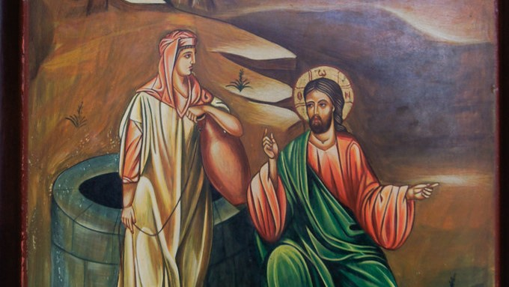

Bickenhill

- The next PCC meeting will be on 22nd March after the service.



