Services for next week:  Hampton-in-Arden  Thursday 12th November  10am Holy Communion  Sunday 15th November  8.15am Common Worship Eucharist  11am Family Eucharist  6.30pm Evensong  Bickenhill  Sunday 15th November  11.00am Matins  Barston  Sunday 15th November  9.45am Prayer Time  10.30am Morning Prayer. Matt will be preaching.  Readings:  1 Thessalonians 5:1–11 and Matthew 25:14–30  We pray for:  Judy Middleton, David Mort, Ann Hall, Tony Worthington, Mona Cardall, Dot Barton, Richard Herne, David Vickers, Vickey Cardwell, Chris and Michelle Cluley, Kevin, Michele Garrison, Owen Cooling, Rev. Stuart Dimes, Paul Pilkington-Birch, Roger Abrahams, Morris Dobbie, Doreen Morris, Robin Mortimore, Keith Ward, Rick Smallwood, Gwen Eley, Pauline Tutchings and Trixie Harman.  We also pray for the families of those who have died, in particular Dr Alfred “Clem” Cottrill.  If you would like someone to be prayed for, please let us know:  office@hamptoninardenchurch.org.uk  Please recycle this pew slip. |  | 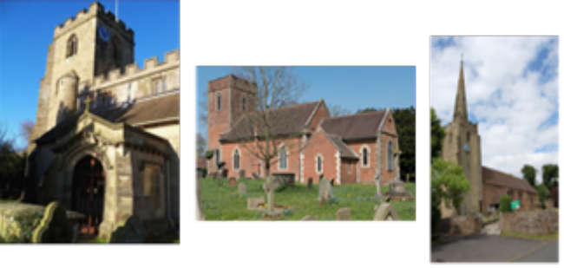  Hampton. Barston. Bickenhill.  Three Churches Together.  Sharing God’s Love, Growing Faith and Worshipping Together.  8th November 2026 – Remembrance Sunday  Thought for the week  “Blessed are the peacemakers; they will be called children of God.”  Who is Jesus talking about? They have seven characteristics.  They are poor in spirit (:3), so look to God because they know that in and of themselves they are spiritually bankrupt. They mourn over their own sins as well as the sins of the world (:4). They are meek, humble people who are prepared to wait for the Lord to put things right (:5).  They hunger and thirst for justice (:6). They are merciful (:7), and pure in heart (:8), seeking peace without ulterior motives. And they are likely to face rejection because of standing with Jesus for justice (:10).  Does this describe the leaders of the world to whom we often look to bring peace in the world? Does it describe us? It should describe those who follow Jesus, the Prince of Peace.  Alan Black  Collect  God, our refuge and strength,  bring near the day when wars shall cease  and poverty and pain shall end,  that earth may know the peace of heaven  through Jesus Christ our Lord.

Hampton  • PCC meeting Wednesday 11th November at 7.30pm in the church office.  • Sunday 15th November: Baptism of Atticus during the 11am service.  • Tea and Toast Stay and Play for babies, toddlers and preschoolers, 9–10.15am on Friday 20th November in the church hall.  • Ladies’ Breakfast 9–10am Saturday 21st November in the church hall.  • Christmas Fair Saturday 12th December in the Fentham Hall, 10am–3pm. Please speak to Anna about helping on the rota. Bottles and chocolates are needed for the bottle pull and chocolate tombola.  • Christmas cards featuring an original oil painting of the church by Michael Culverwell are available for £1.50 each, in aid of church funds. Order forms are at the back of church.  Barston  • Thank you to everyone who decorated the church for Remembrance Sunday. A great team effort. Thank you to Rachael for leading the service and Chris for preaching.  • Wednesday 11th November: Eastcote Park Service of Remembrance at 11am, led by Rev. Nick Parker.  • Saturday 14th November: Christmas Fayre at St Swithin’s House, 10am–1pm. Handmade gifts, cards, preserves, cakes, bric-a-brac and jigsaws. Entry £3, including mulled wine, mince pies and coffee.  • Saturday 14th November, 2pm: Baptism of James, son of Jake and Laura Harrhy, who were married here last year. Please pray for the service and for Stuart as he comes to officiate.  • Wednesday 18th November: PCC meeting at 7.30pm in St Swithin’s House.  • Saturday 28th November: Advent Quiet Morning, 10am–12 noon, Old Hall, Temple Balsall. Led by Rev. Debbie Collins. Theme: Hope, Love, Joy, Peace. Please speak to Linda if interested.  • Sunday 29th November: Toy Service with a guest speaker from Birmingham City Mission. Donated toys will go to children in the city. Suggested gifts are listed on handouts on the porch table. |  | Barston continued  • Please continue to pray for Robin, the medical team caring for him, and Sue and family as they visit daily.  Bickenhill  • Hampton Christmas Fair on 12th December: Bickenhill will have a table. Please bring new items, handmade crafts and Christmas items. A collection box will be at the back of church.  • Next PCC meeting is 29th November after the service.  Hampton-in-Arden Village Fair  

