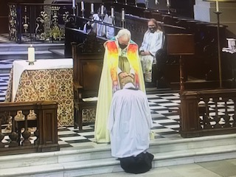

Revd. Clare Dean being ordained as a Priest 27th June 2021

and taking her first Eucharist on 4th July