**Services for next week:**

**Hampton-in-Arden**

**Thursday 10th**

10am Communion

**Sunday 13th**

8.15am B.C.P.

11am Eucharist

6.30pm Compline

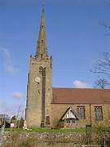

**Bickenhill**

**Sunday 13th**

11am Eucharist

**Barston**

**Sunday 13th**

9.45am Prayer Time

10.30am Holy Communion Service

**Readings for next week**: Psalm 118. 1-2, 19-29; Luke 19. 28-40

**We pray for:** Bob Middleton, David Mort, Mike Beasley, Ann Hall, Tony Worthington, Rene Sumner, Derrick Hill, Angela Jones, Mona Cardall, Dot Barton, Richard Herne, Barrie and Mavis Thompson, Debby Read, David Vickers, Sue Restall and Ronnie Boswell.

Rick Smallwood, Paul Pilkington-Birch, Val Sharp, David Scannell, Colin McDonald and Gordon O’Conner.

We also pray for the families of those who have died; Celia Heron, Richard Bibbings, Karoline Dearden, David Howells, Ivan Eley, June Hand, John Vaughn, Elizabeth Pakeman, Andrew Sumner and Roger Grain.

(Please note, to keep the names of those we pray for up to date, they will be reviewed each month, so if you would like people to be prayed for do let us know at [office@hamptoninardenchurch.org.uk](mailto:office@hamptoninardenchurch.org.uk))

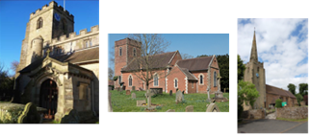

**Hampton. Barston. Bickenhill.**

**Three Churches Together.**

**Sharing God’s Love, Growing Faith and Worshipping Together.**

**6th April 2025- Passiontide**

Isaiah 43. 16-21; John 12. 1-8

**Thought for the week**.

Our days are rarely all one thing or another. We live lives that are a mixture of good and bad, happy and sad, comfortable and painful. We see news of earthquakes and warfare and then walk out into the beauty of spring. Personally, we grapple with worries and conflict, as birdsong streams in through the open window.

Judas couldn’t cope with this. He couldn’t cope with Jesus having a mission to the poor and at the same time being anointed with expensive, perfumed oil. He couldn’t cope with Jesus continuing to love him, even washing his feet, although he was resentful and dishonest.

Jesus modelled for us lives that are at the same time generous and receptive of the generosity of others. He showed us how to channel God’s love to others while taking time to bathe in that love ourselves. That's how grace works.

**M.C.**

**Collect**

Gracious Father,

you gave up your Son

out of love for the world:

lead us to ponder the mysteries of his passion,

that we may know eternal peace

through the shedding of our Saviour’s blood,

Jesus Christ our Lord.

Eastcote Park Care Home are asking for **donations of Easter Eggs** or sweets to help support Smiling Faces Charity to bring a smile to families in need this Easter. If you can help please bring to church and they will be dropped off at the home. We need to have these by next Sunday 13th please.

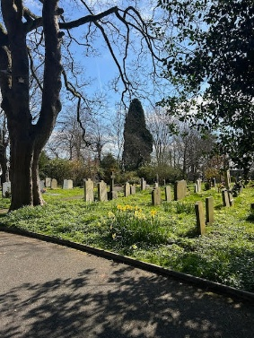**Filling Station** Monday 7th April at 7pm for 7.30pm. The speaker is Laura Brett who has some amazing stories of leading people of all ages to Christ in some very unusual places and situations. An inspiring evening is being looked forward to by the team. We hope you can join us. She is a member of the Filling Station staff and lived in Harrogate.

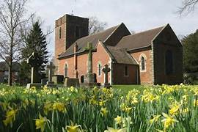

**Hampton**

* We welcome Georgie Leonie from **Acorns Children’s Hospice** to our 11am service and look forward to hearing how our donations are used to finance their work.
* Our church **A.P.C.M** (Annual Parochial Church Meeting) will be held at 7.30pm on April 9th in church. Everyone is encouraged to attend.
* Last session of our **Lent course** at Hampton on 10th April. 10.45am for coffee in the church hall, discussion 11-12 noon. All welcome.
* The joint choirs of Hampton and St. Peter’s, Balsall Common, will again lead **our service of music and readings for Holy Week**. **Sunday 13th April** (Palm Sunday) at 6pm at St. Peter’s Church and then on **Friday 18th April** (Good Friday) at 7.30pm at **Hampton Church.** Kim would be delighted if you could come to support.
* Kim is looking for readers for our Good Friday service (18th April at 7.30pm). If you’d like to read, please email him at [kim.rawson@btinternet.com](mailto:kim.rawson@btinternet.com) or text him on 07527 540529, many thanks.
* **Easter trail for children** will take place on Friday 18th April 10am-12noon.
* You may have noticed our **new foodbank collection bin** in the link room, kindly provided by the Community Essentials Foodbank. Let’s see how quickly we can fill it for collection!

**Barston**

* **Thanks** once again to Libby and Richard for another great morning of food and fellowship yesterday. The perfect way to start a weekend.
* **Lent Course week 5** – final session. Wednesday April 9th at 1pm. Well that’s come around quickly. It’s been a very helpful and personal journey as we read the daily reflections and Jo’s writing has certainly made us question and think about our faith journey and our attitudes to creation in this season of Lent. Big thank you to Martin for leading us through this course. NB a soup lunch will be available from 1pm prompt if you would like to come an hour earlier to share a simple meal together, then the meeting will start at 2pm. Tea and cake after the meeting as usual.
* **Holy Week -Maundy Thursday evening**, supper with communion afterwards. 6.30pm for 7pm. IMPORTANT -PLEASE SIGN THE LIST ON THE TABLE IF YOU ARE COMING. £5. Alan and Valerie Golton will be with us over Easter, staying with Paul and Vivian. The evening will start with a simple two-course supper then we will be having a short service of Communion where we will share bread and wine together, as Jesus did with his disciples, in the upper room. We hope you would like to be there.
* **Easter cards for the village** – Thank you to the team for organising the planning, collating, printing, collecting and distributing the cards to the village. Great team work!
* On Saturday 19th April at 10am we will be **decorating the church** for Easter.