Services for next week:
Hampton-in-Arden

Thursday 21st May
10am Communion

Sunday 24th May
8.15am B.C.P
11am Eucharist with JAM Children’s Group
6.30pm Study Group

Bickenhill

Sunday 24th May
11am Eucharist

Barston

Sunday 24th May
9.45 Prayer Time
10.30am Morning Prayer – Matt V will be preaching.

Readings for next week:
Acts 2 1-21; John 20.19-23

We pray for: Judy Middleton, David Mort, Ann Hall, Tony Worthington, Mona Cardall, Dot Barton, Richard Herne, David Vickers, Vickey Cardwell, Chris Cluley and Barbara Waring. Paul Pilkington-Birch, Richard Mitchell, Roger Abrahams, Morris Dobbie, Doreen Morris, Robin Mortimore, Michelle Cluley, Keith Ward, Jenny Miller, Rick Smallwood, Graham Stidworthy, Gwen Eley and Jenny Miller.
We also pray for the families of those who have died; David Moore, Pauline Booker, Anne Oliver-Jones and Angela Jones. If you would like people to be prayed for do let us know office@hamptoninardenchurch.org.uk

Please recycle this pew slip.
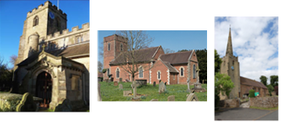

Hampton. Barston. Bickenhill.

Three Churches Together.

Sharing God’s Love, Growing Faith and Worshipping Together.

17th May 2026- 7th Sunday of Easter
Acts 1 6-14; John 17.1-11
Thought for the week
Before his death and resurrection Jesus prayed to the Father about what was soon to happen to him. He prayed aloud so the disciples could hear, and we could perhaps call it a prayer of consecration because Jesus was dedicating himself to God. He was concerned for the glory of God, for his final righteous deeds, and for his disciples.
He then prays for his followers, that they may know the Father and be kept in his name.
Only over time does everything that is happening become clear to them and only in stages.
After the Cross and resurrection, following Jesus’ ascension into Heaven, the disciples are looking upwards, wondering what comes next. Jesus didn’t give them a timetable or a plan. Instead he gave them a promise. The Holy Spirit will come and they will be his witnesses. So they return to their lives, not with answers, but with obedience, meeting together in prayer, waiting with trust.
Together these readings remind us that we do not always know what is coming next. Yet we are called to be faithful where we are, rooted in prayer, held by Christ, and open to the Spirit. MM

Collect
Risen, ascended Lord,
as we rejoice at your triumph,
fill your Church on earth with power and compassion,
that all who are estranged by sin
may find forgiveness and know your peace,
to the glory of God the Father.
Hampton
- Thanks to all those who helped at our Oversight Area Ascension Day service. It was lovely to worship together with those from surrounding churches.
- Sending our love, prayers and best wishes to Sarah Vaughan who is moving away from the area. Thank you for providing the cakes after the 8.15am service!
- Friday 22nd May -Tea and Toast Stay and Play 9am in the church hall. Next JAM session on Sunday 24th May.
- Funeral of Angela Jones in church at 11am on Tuesday 19th May.
- Funeral of Anne Oliver-Jones in church at 2pm on Friday 22nd May.
- Any more volunteers for the church cleaning rota, please contact Kim or Anna.

Hampton Village Festival Saturday 4th July and Open-Air service/ Big Lunch Sunday 5th July. We still need volunteers to help run stalls on the Saturday daytime please. We are collecting good quality soft toys for a Teddy Tombola and books for a book stall, so get collecting!

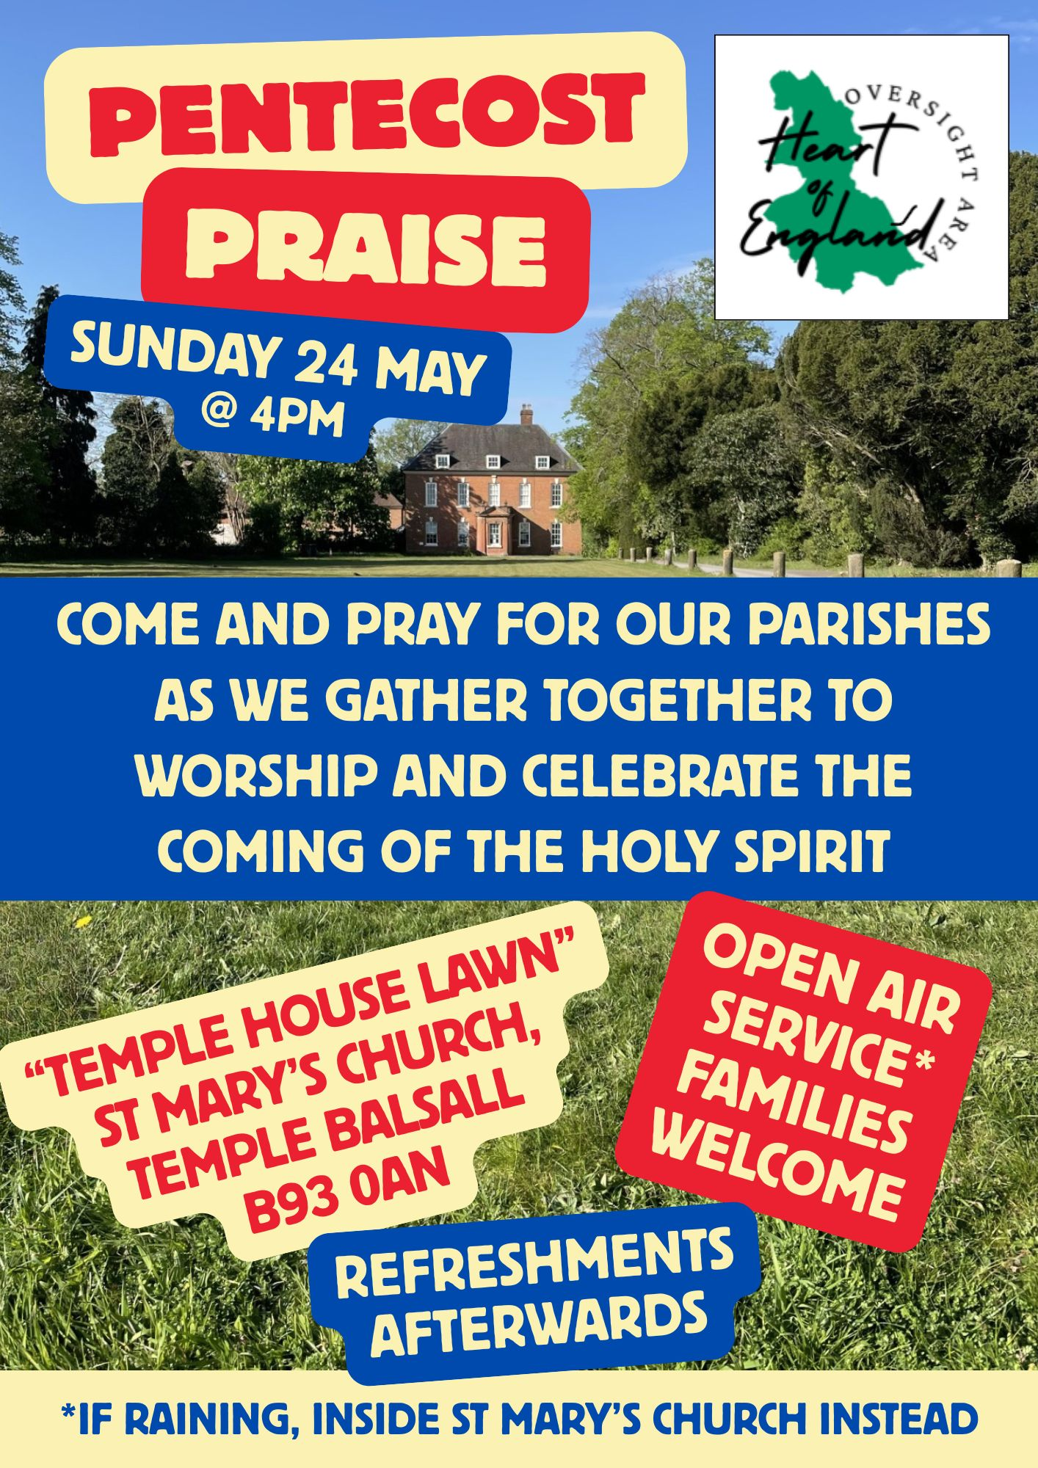

Barston
- Tuesday 19th Hobby House from 10am and Tea Club from 2pm. Both happening at St Swithin’s House. All welcome.
- Wednesday 20th service at Eastcote Park at 11am. Thanks to those from church who are taking this today.The residents really look forward to us going in.
- Wednesday 20th May PCC meet at 7.30pm. Please pray for this very important meeting.
- Friday 22nd Coffee Morning at Eastcote Park from 11am. All welcome.

St Swithin’s Weekend 11th and 12th July. Flowers in church. Crafts by Inspire Textile Group. Cream teas in St. Swithin’s House and gardens. Sunday service in the garden with Esther, Bishop of Birmingham. Lunch.

Bickenhill

- The APCM took place recently. Thank you to all those who have taken on roles and been appointed to the PCC. Also thank you to Ken and Peter who continue as Churchwardens; the work they do is very much appreciated.
- We shall be having a stall at the Hampton Village Festival, which is on 4th July. Please can you bring any items you no longer want or use. If you have a craft skill and would like to donate items to sell this would be very much appreciated.
- The work in the churchyard starts on 10th June; unfortunately a couple of trees need to be felled and several trees will be pollarded. Although we have someone to cut the grass it is getting increasingly difficult to keep on top of the weeds and keeping the graves tidy. If you would like to help please speak to the churchwardens or if you would like to make a donation to the churchyard fund then please get in touch.
- The wedding of Sean and Bella will take place on 28th May.
- Next PCC meeting 26th July after the service.

