Services for next week:
Hampton-in-Arden

Thursday 23rd April
10am Communion

Sunday 26th April
8.15am B.C.P.
11am Eucharist
6.30pm Sunday Evening Book Club

Bickenhill

Sunday 26th April
11am Eucharist

Barston

Sunday 26th April
9.45 Prayer Time
10.30am Morning Prayer, with Alan Black.

Readings for next week:
Acts 2 42-end; John 10.1-10

We pray for: Bob Middleton, Judy Middleton, David Mort, Ann Hall, Tony Worthington, Mona Cardall, Dot Barton, Richard Herne, David Vickers, Vickey Cardwell and Chris Cluley. Paul Pilkington-Birch, Richard Mitchell, Roger Abrahams, Morris Dobbie, Doreen Morris, Doug Holdom, Robin Mortimore, Michelle Cluley, Keith Ward, Jenny Miller, Rick Smallwood, Graham Stidworthy, Gwen Eley and Jenny Miller.
We also pray for the families of those who have died; Eileen Taylor, Roger Harrison, Neil Jones, Gerald Boston, John Isham, Joan Wilson, David Moore and Pauline Booker. If you would like people to be prayed for do let us know at office@hamptoninardenchurch.org.uk
Please recycle this pew slip.
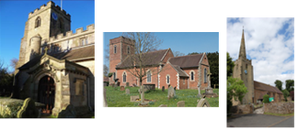

Hampton. Barston. Bickenhill.

Three Churches Together.

Sharing God’s Love, Growing Faith and Worshipping Together.

19th April 2026- 3rd Sunday of Easter
Acts 2 14, 36-41; Luke 24.13-35

Thought for the week
The readings for this week both describe moments when confusion turns into understanding.
In the Gospel of Luke, an Easter account, two disciples travel from Jerusalem, struggling to make sense of the death of Jesus. A stranger joins them and explains the Scriptures, showing how the Messiah’s suffering had always been part of God’s plan. Only later, when he breaks bread with them, do they recognise it is Jesus. They look back and realise that their hearts had
been “burning within them” as he spoke.
In Acts at Pentecost we see a similar moment on a much larger scale. Simon Peter proclaims that the crucified Jesus has been made “both Lord and Messiah”. The crowd listening are “cut to the heart” and ask “What shall we do?” Peter calls them to repent, be baptised, and receive the
gift of the Holy Spirit.
Both stories follow the same pattern: first confusion, then Scripture explained, hearts stirred, and lives changed.
Christian faith is about recognising the risen Christ and responding to him.
The question asked at Pentecost is still relevant today: “What shall we do?” The answer, is an invitation to discover the new life that is found in Jesus Christ. MM

Collect
Risen Christ,
you filled your disciples with boldness and fresh hope:
strengthen us to proclaim your risen life
and fill us with your peace,
to the glory of God the Father.

Please note that Rev. Stuart will be on annual leave from Sunday 19th April until Thursday 30th April inc.
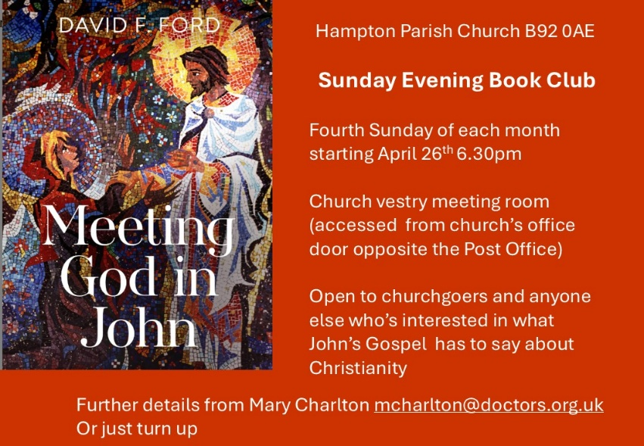

Hampton
- Tea and Toast next meeting Friday 24th April 9-10.15am in the church hall.
- Tonight is our Sunday Evening Book Group: Every 4th Sunday, we meet in the vestry at 6.30pm to delve deeper into our faith and scripture in friendly and supportive conversation. After Easter we shall be basing our discussion on the book "Meeting God in John" by David Ford. New participants and occasional attendees are always welcome. You don't need to sign up in advance but if you'd like a copy of the book (£9.30) please let Mary know mcharlton@doctors.org.uk or source one from your favourite book supplier! If the price is a barrier to coming, let Mary know and we'll get round that.



Barston
- The APCM. This was held a week ago. It was well attended and a good meeting.
It included reports on different aspects of church life, vicars report, treasurers report. This was the final report from Ian as he is retiring from this role after 20 years of faithful service. He was presented with a thank you card and gift. We are delighted to let you know that Adrian has agreed to take on the role from now with Ian guiding him.
This was a huge answer to much prayer .
The role of churchwarden is to be shared by the Oversight group, Helen, Shirley, Linda, Charles and Richard.
Linda was nominated to become Deanery Synod rep along with Rachael who was re- elected. The term is for 3 years.
The PCC remains the same. Lay readers are co-opted. Helen was also presented with a gift as she was standing down from role at church warden. Rachel was also thanked with a gift for all the work she does behind the scenes as secretary.
- Tuesday 21st Hobby House at 10am and Tea club at 2pm in the house with plenty of homemade cake and chatting. All welcome.
- Wednesday 22nd Eastcote Park – church members will be leading a service there for residents.
- Big Breakfast 9th May (NB this is second Saturday due to a Bank Holiday on 2nd May).
- Date for Diary – May 9th Prayer Day in St. Swithin’s House.St. Swithin’s weekend 11/12th July.



