Services for next week:
Hampton-in-Arden

Wednesday 18th February
7.30pm Ash Wednesday Service (Isaiah 58. 1-12; John 8. 1-11)

Thursday 19th February
10am Holy Communion

Sunday 22nd February
8.15am B.C.P
11am Eucharist with JAM children’s group
6.30pm Study

Bickenhill

Sunday 22nd February
11am Eucharist

Barston

Sunday 22nd February
9.45 Prayer Time
10.30am Holy Communion

Readings for next week:
Romans 5. 12-19 (Hampton Genesis 2. 15-17 and 3. 1-7 for 11am service); Matthew 4. 1-11.

We pray for: Bob Middleton, Judy Middleton, David Mort, Mike Beasley, Ann Hall, Tony Worthington, Angela Jones, Mona Cardall, Dot Barton, Richard Herne, David Vickers, Vickey Cardwell and Chris Cluley. Paul Pilkington-Birch, Val Sharp, Richard Mitchell, Roger Abrahams, Morris Dobbie, Doreen Morris, Doug Holdom, Rev. Stephen Mayes, Robin Mortimore, Michelle Cluley, Keith Ward and Rick Smallwood.
We also pray for the families of those who have died; Betty Clarke, Alan Bloomfield, Wendy Raby, Dr. John Hodgson, Eileen Taylor, Roger Harrison, Neil Jones, Gerald Boston, John Isham, Joan Wilson and David Moore. If you would like people to be prayed for do let us know at office@hamptoninardenchurch.org.uk

Please recycle this pew slip.
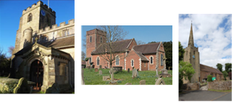

Hampton. Barston. Bickenhill.

Three Churches Together.

Sharing God’s Love, Growing Faith and Worshipping Together.

15th February 2026- Sunday before Lent
2 Peter 1. 16-end; Matthew 17. 1-9.

Thought for the week

In 2 Peter 1:16-end & Matthew 17:1-9 we are invited to look again at who Jesus truly is. The disciples are bearing witness to what they had actually seen. They encountered Jesus’ glory firsthand, and so our faith rests not on speculation but on something utterly reliable: God revealing himself in ways we can trust.
On the mountain of the Transfiguration, Jesus shines with a glory that briefly opens heaven to the disciples’ sight. Moses and Elijah appear with him, with Moses representing the law and Elijah the prophets, together pointing to Jesus as the fulfilment of all God’s purposes.
When the Father declares, “This is my beloved Son... listen to him,” it is both revelation and instruction: a call to trust Christ and to remain awake to God’s presence and glory. That call echoes in Colossians 4:2: “Devote yourselves to prayer; stay alert in it with thanksgiving.”
Through prayer we can recognise God when he reveals himself — and to stay attentive even when we don’t yet understand what we are seeing. M.M.

Collect
Holy God,
you know the disorder of our sinful lives:
set straight our crooked hearts,
and bend our wills to love your goodness
and your glory
in Jesus Christ our Lord.
Amen.

Hampton
- Pancake Party February 17th 2-4pm at church.
- Ash Wednesday service 18th February at 7.30pm.
- Hampton Lent Course starts Feb 19th. If you are interested in the course but unable to attend at this time, please contact Mary mcharlton@doctors.org.uk
- Ladies’ Breakfast 9-10am in the church hall on 21st February.
- Eco-Lent 26 course starts on Tuesday 24th February 7.45pm at Knowle Parish Church. Postcards with further details available on the table by the South door.
- A reminder that Chronicle subscriptions are now due!
- World Day of Prayer is on March 6th at 7.30pm at St. Philip’s Church, Dorridge. Lifts available, please contact the church office. Worship in the words of women of Nigeria entitled, “I Will Give You Rest. Come.”.
- Our church APCM will be on March 26th. To be elected or to vote you need to be on the electoral roll. Forms available on the red board in church. Reports to Anna asap!
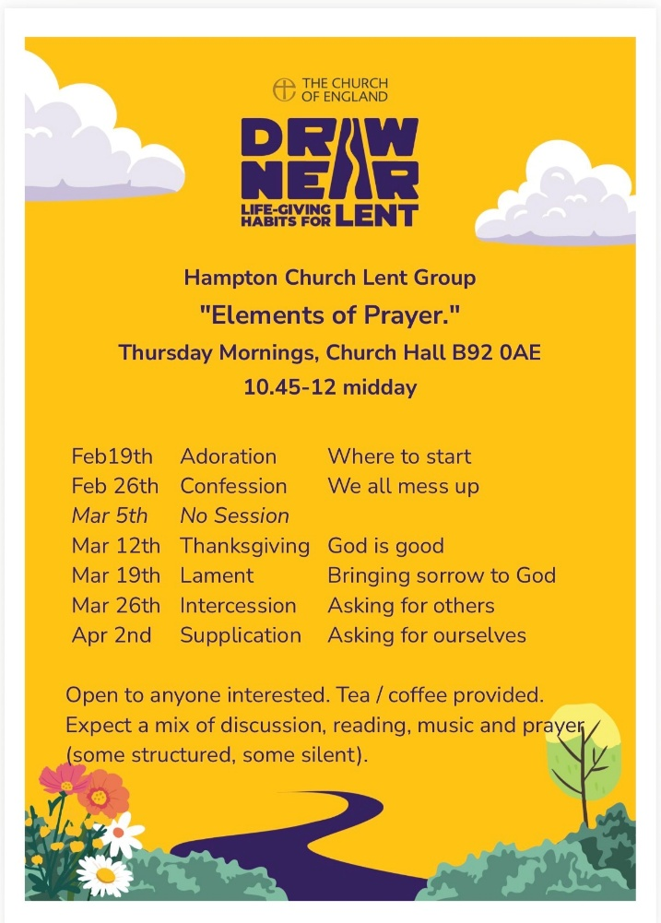

Barston
- Monday 16th Rota Planning Meeting. 2pm at Whatcote Green.
- 17th February from Tea Club from 1.30pm, pancakes and cake. Donations for Marie Curie. Please invite friends and neighbours. All welcome.
- Lent Course starts on Wednesday 18th February in St. Swithin’s House at 1.45pm for a 2pm start. Refreshments will be served after the meeting. All welcome. More details from Helen or Martin. Hope to see you there.
- February 19th St. Swithin’s House Trustee Meeting.
- Churches Together Lent Breakfasts start on Saturday 21st February and for the next four Saturdays at Balsall Common Methodist Church. A simple breakfast will be served from 8.45am. Talk at 9am followed by Q & A at 9.25am. Meeting ends at 9.45am. The theme this year is “books”. Five different speakers talk on a book that means a lot to them. Flyers with more detail on the table in the porch.

Bickenhill


- The next PCC meeting will be on 22nd March after the service.

