“Welcome and Congratulations”
Please add the time, date and place of wedding
.
Parish Connection to the Parish Church of Hampton in Arden
Please indicate how you are connected with this church here
You may have several connections with this church, but only one is required. For more information, please contact our Parish
Administrator.

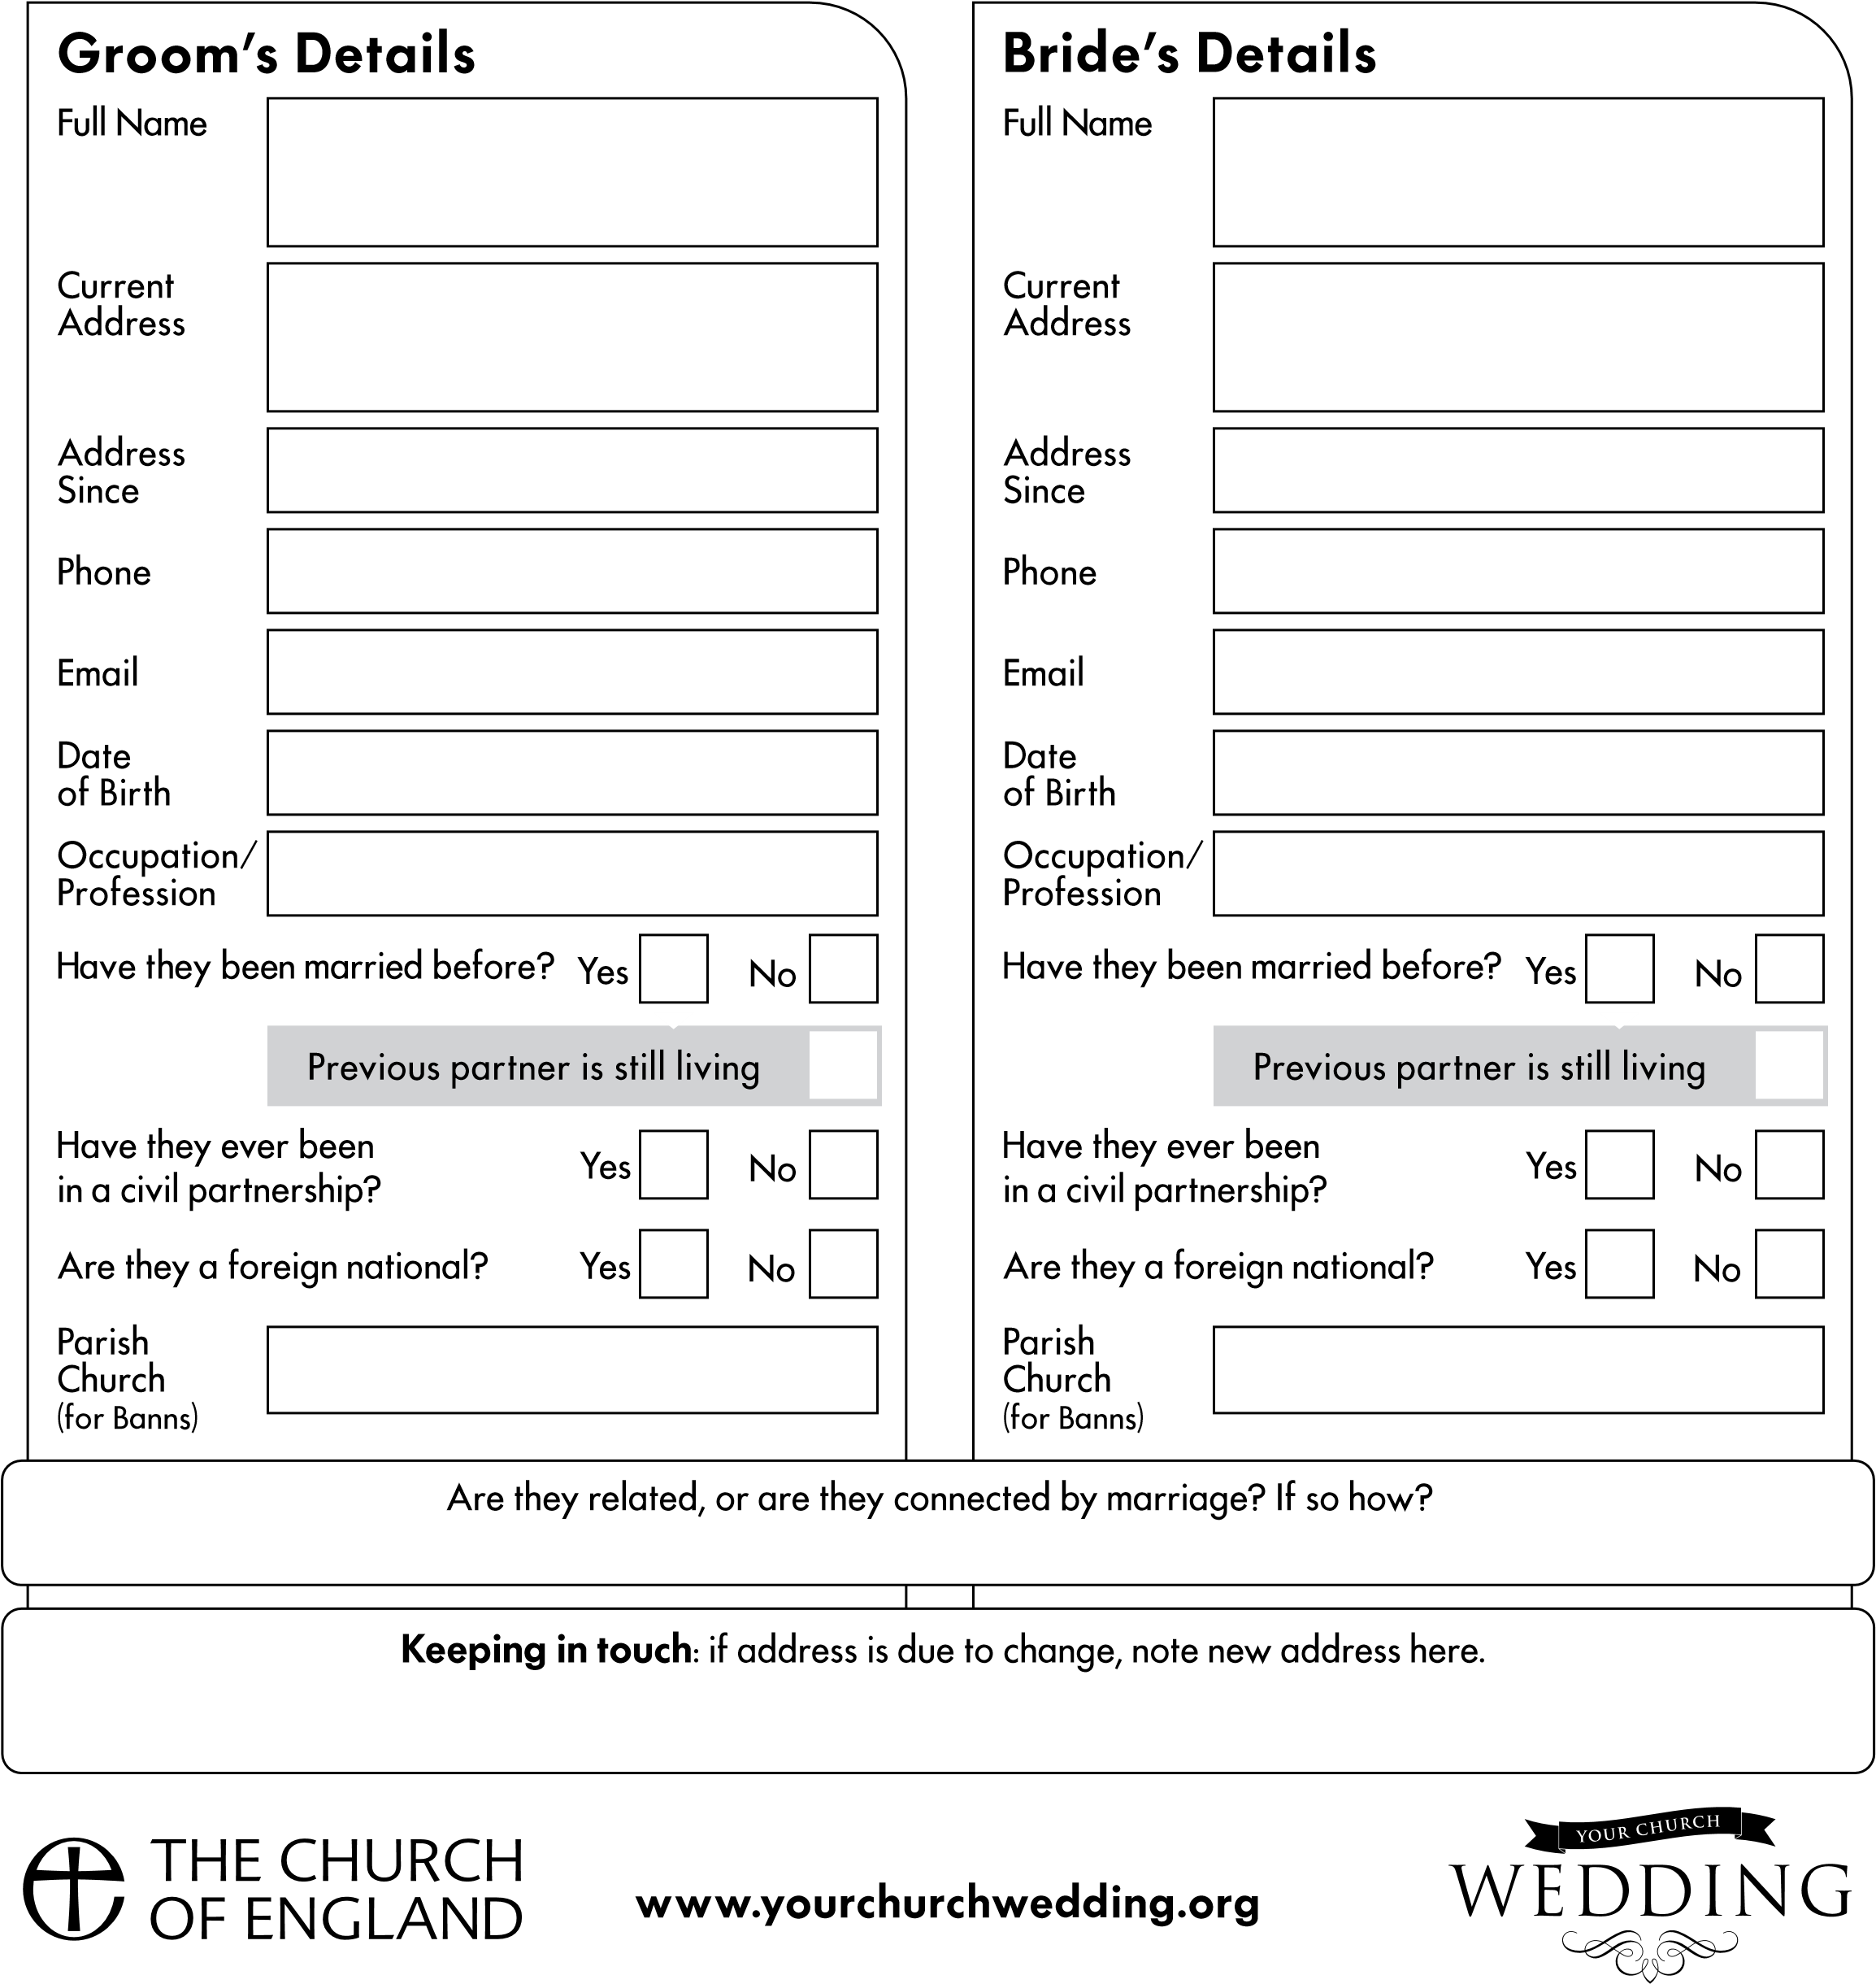
Bride’s Father
Full Name
Occupation/
Profession
Deceased?
Yes
No
Bride’s Mother
Bride’s Parent
Bride’s Parent
Full Name
Occupation/
Profession
Deceased?
Full Name
Occupation/
Profession
Deceased?
Full Name
Occupation/
Profession
Deceased?
Yes
No
Yes
No
Yes
No
Groom’s Father
Full Name
Occupation/
Profession
Deceased?
Yes
No
Groom’s Mother
Groom’s Parent
Groom’s Parent
Full Name
Occupation/
Profession
Deceased?
Full Name
Occupation/
Profession
Deceased?
Full Name
Occupation/
Profession
Deceased?
Yes
No
Yes
No
Yes
No
For the purposes of data protection law, the data controller is the Minister of the parish, Rev Stuart Dimes and the PCC of St. Mary and St. Bartholomew Parish Church, Hampton in Arden.(“PCC”), who will use the information on this form to ensure that the legal requirements relating to the marriage are complied with and to make arrangements for the wedding ceremony. The Minister and PCC will only share the information with those who need to see it for those purposes. Your data may be stored on behalf of the Minister, or the PCC either on systems owned by the Archbishops’ Council of the Church of England or other software. After your wedding, your church would love to keep in touch with you on anniversaries and to let you know about services and events that may interest you. If you are happy for the church to keep in touch with you in this way, please tick this box:
The couples key dates:
First meeting
Prep event(s)
Banns
First
anniversary

Wedding Choices:
Officiant
Entrance
Hymns
Recessional
Reading(s)
Other
Useful contacts for this couple:
Photographer
Videographer
Bells
Choir
Flowers

