

Services for next week:
Hampton-in-Arden

Thursday 9th July
10am Communion

Sunday 12th July
8.15am B.C.P.
11am Eucharist with JAM children’s group
6.30pm Compline

Bickenhill

Sunday 12th July
11am Eucharist

Barston

Sunday 12th July
9.45 Prayer Time in the garden
10.30am Outdoor service in the garden with Esther, Bishop of Aston, followed by coffee and a Ploughman’s Lunch.

Readings for next week:
Romans 8. 1-11; Matthew 13. 1-9, 18-23

We pray for: Judy Middleton, David Mort, Ann Hall, Tony Worthington, Mona Cardall, Dot Barton, Richard Herne, David Vickers, Vickey Cardwell and Chris and Michelle Cluley. Paul Pilkington-Birch, Richard Mitchell, Roger Abrahams, Morris Dobbie, Doreen Morris, Robin Mortimore, Keith Ward, Rick Smallwood, Gwen Eley, and Gary Wood.
We also pray for the families of those who have died; Anne Oliver-Jones, Angela Jones, Janet Griffiths, Barbara Waring and Dawn Byrne. If you would like people to be prayed for do let us know office@hamptoninardenchurch.org.uk
Please recycle this pew slip.
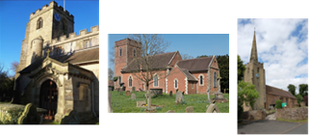

Hampton. Barston. Bickenhill.

Three Churches Together.

Sharing God’s Love, Growing Faith and Worshipping Together.
5th July 2026- Trinity 5
Romans 7. 15-25; Matthew 11. 16-19, 25-end

Thought for the week

“Come to me, all you that are weary and are carrying heavy burdens, and I will give you rest.’
During the recent heat wave, I was touched to hear that Adam in the Corner Shop was
offering free delivery on any order, however small. What a practical way of providing rest, at a time when most of us were unusually weary.
We all need to be on the lookout for ways to relieve one another of our burdens, physical
and otherwise. We are the Body of Christ. As St Teresa told us “Christ has no body but ours, No hands, no feet on earth but ours.” It’s up to us to fulfil this promise of Jesus.
And Jesus will give rest to our souls. Even in 34°C.
Mary C

Collect

Almighty God,
send down upon your Church
the riches of your Spirit,
and kindle in all who minister the gospel
your countless gifts of grace;
through Jesus Christ our Lord.



Hampton
- PCC meeting 8th July at 7.30pm in the church office.
- Next Tea and Toast Friday 10th July 9am in the church hall.
- The funeral of Janet Griffiths will be held at 1pm on Monday 13th July at Hampton Church. Tea and cake in the church hall afterwards. Committal service 3pm at Robin Hood for family only. If anyone is available to help serve tea/coffee on the afternoon, please let Anna know.
- The funeral of Dawn Byrne will take place in church at 12pm on Friday 24th July.
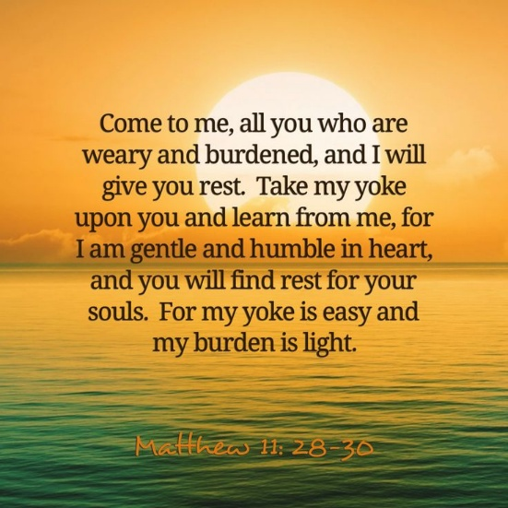

Barston
- Next week, 12th July, we will be having coffee and a Ploughman’s lunch prepared by Libby and Richard, following the outdoor service. Donations for this would be appreciated.
- St. Swithin’s Weekend is nearly here!
Preparation days Thursday and Friday from 10. If you are BAKING please bring cakes over to the House on Friday between 10am and 4pm, OR on Saturday if possible.
If you have offered to help you should have been sent a rota schedule. If you have not received it please get in touch with Linda or Karen. Please invite friends and neighbours. No set charge. Donations - card or cash. Weather looks dry – phew! Please pray for the weekend that it might be one of joy and that all visitors will feel welcomed. We pray that they enjoy our lovely church, refreshments and being here. Also for the visit of the Bishop, as she takes part in the service and sees our church and house for the first time.
- Monday 6th at 7pm Band practice for Sunday in church.
- Tuesday 7th at 8.30am Open the Book team at George Fentham School and Wednesday 8th 8.30am at Springfield School. Please pray for these presentations that the children will enjoy and learn from them.
- Tuesday 7th Hobby House at 10am and Tea Club in the garden at 2pm. All are welcome.
- Churches Together meeting on 7th at 7pm for 7.30pm start.The Parish Representatives meet every quarter and this time is our turn to host.
- Wednesday 8th Eastcote Park service at 11am for residents and visitors. All are welcome.


Bickenhill

- Next PCC meeting 26th July after the service.

