Services for next week:
Hampton-in-Arden

Thursday 22nd October
10am Communion (SR/MC)

Sunday 25th October
8.15am Morning Prayer with Alan Black
11am Eucharist (SR)
6.30pm Study (MC)

Bickenhill

Sunday 25th October
11am Eucharist

Barston

Sunday 25th October
9.45 Prayer Time
10.30am Morning Prayer

Readings for next week:
Colossians 3.12-17; Matthew 24. 30-35

We pray for: Judy Middleton, David Mort, Ann Hall, Tony Worthington, Mona Cardall, Dot Barton, Richard Herne, David Vickers, Vickey Cardwell, Chris and Michelle Cluley, Ann Hall, Kevin, Michele Garrison, Owen Cooling and Rev. Stuart Dimes. Paul Pilkington-Birch, Roger Abrahams, Morris Dobbie, Doreen Morris, Robin Mortimore, Keith Ward, Rick Smallwood, Gwen Eley, Pauline Tutchings, Trixie Harman and Peter Smith.

We also pray for the families of those who have died; Janet Griffiths, Barbara Waring, Dawn Byrne, Audrey Clayton Pearce and the McDonald family. If you would like people to be prayed for do let us know office@hamptoninardenchurch.org.uk

Please recycle this pew slip.

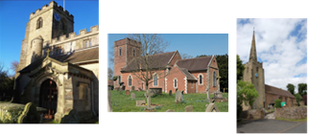

Hampton. Barston. Bickenhill.

Three Churches Together.

Sharing God’s Love, Growing Faith and Worshipping Together.

18th October 2026- Trinity 20

1 Thessalonians 1.1-10; Matthew 22. 15-22

Thought for the week

Jesus is asked whether it is right to pay taxes to Caesar. It is a question designed to trap him, but his answer invites us to consider something deeper: give to God what belongs to God.
The coin carries Caesar’s image. We are made in God’s image. What we offer to God, then, involves our whole selves: our time, our choices, and the way we treat other people.
That can be challenging. We have responsibilities and concerns which take our attention, and it is easy to leave God until we have a quieter moment.
Yet God is already present in our everyday lives. Paul recognised this in the Thessalonians, whose faith was expressed through love and perseverance.
Giving ourselves to God begins with remembering that we belong to him and allowing his love to shape whatever we do next. MM

Collect

God, our light and our salvation:
illuminate our lives,
that we may see your goodness in the land of the living,
and looking on your beauty
may be changed into the likeness of Jesus Christ our Lord
Hampton

- Saturday 31st October Children’s Light Party in the hall and church, 3pm. Please spread the word to local friends and family and do let Jess know if you are willing and able to help in any way.
- Sunday 1st November All Souls’ Service 6.30pm in church. Please add names to the list in church or e-mail them to office@hamptoninardenchurch.org.uk
- Remembrance Service Sunday 8th November at 10.15am. If anyone is willing to hand out service sheets at the war memorial and collect money for the Royal British Legion, please let Anna know.
- Christmas Fair Saturday December 12th in the Fentham Hall 10-3pm. Please speak to Anna if you can go on the rota to help for a couple of hours. This year we will be collecting bottles (of any sort, from vinegar to champagne!) for a bottle pull and chocolate for a chocolate tombola.
- Christmas cards featuring a design from an original oil painting of our church by Michael Culverwell are being sold in aid of church funds. Priced at £1.50 each, you can find a card and order form on the table as you come into church.
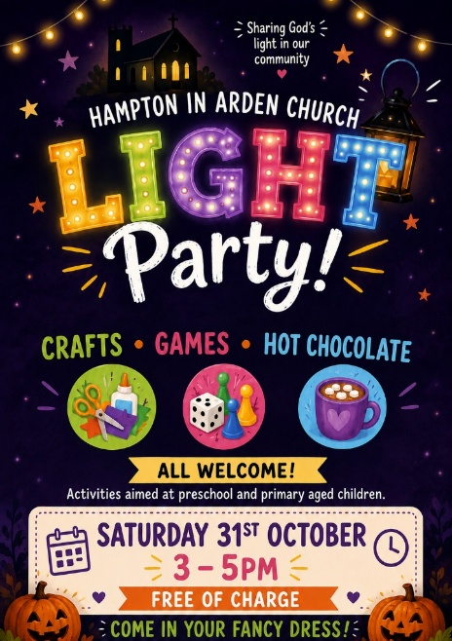

Barston
- The Barston newsletter for October/November is available from the table in the porch. Please pick up a copy. Thanks to Mary for writing our news.
- Open the Book two assemblies down, two more this week. Tuesday 20th we are at Lady Katherine Leveson at Temple Balsall at 9am. Friday 23rd we are at Springfield School at 9am. Please pray for this vital ministry to our local schools as Bible stories are acted out by the team. It went well this past week.
- Tuesday 20th Hobby House from 10am in the Institute and Tea Club from 2pm in the House. Please consider coming and having a cuppa, cake and chat.
- Wednesday 21st Eastcote Park service for residents at 11am. Please pray for Charles who leads this team to provide this vital outreach.
- Churches Together at 7.30pm, the last meeting of this year at St. Peter’s, Balsall Common. This is a great way to work more collaboratively with churches in our area. Group is led by Suzy, vicar of St. Peter’s. Next event is Churches Together Coffee Morning on Saturday 1st November from 10.30am at the Jubilee Centre (behind Tesco and Costa in the centre of Balsall Common).
- Big Breakfast date change – now 31st October.
- Eco-Tip Remember to use your food recycling bin now that this service is available in our borough. It includes tea bags and coffee granules.
- Christmas Fayre November 14th in St. Swithin’s House, 10am-1pm.

Bickenhill

- Thank you to everyone who contributed items at our Harvest Service recently. The Food Bank very much appreciated our donations. Thanks also to Alison Buckler for making the Church look so beautiful with flower arrangements.
- Thank you to everyone who attended the skittles afternoon recently . Fun was had by everyone, and we raised £200 for Church Funds.
- We said a fond farewell to Carol Linfield recently who has supported us as a Lay Reader for many years. We wish her well in her retirement and hope to see her in the congregation in the coming months.
- Please pray for the PCC as they plan our future finances.

