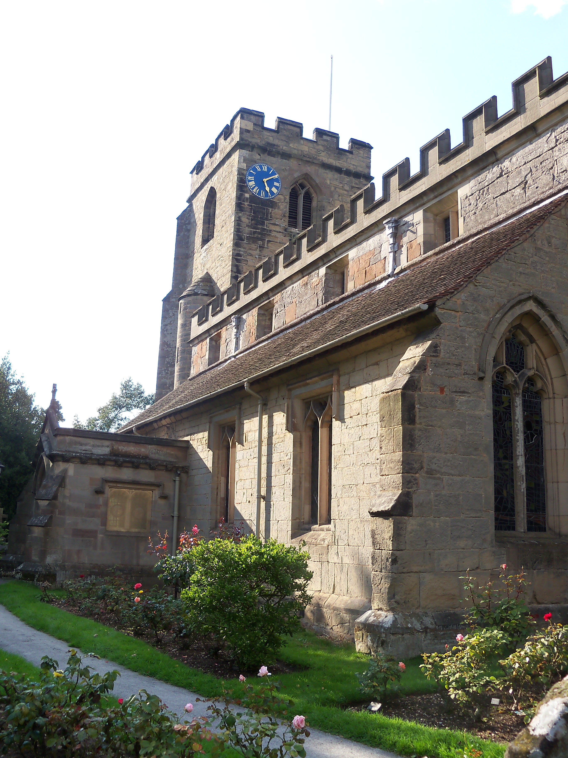

THE PARISH CHURCH OF

ST. MARY AND ST. BARTHOLOMEW

HAMPTON-IN-ARDEN

The amount you pay for your wedding is mostly legal fees paid to the Diocese and payments to our organist, choir and bellringers. As a church and a charity, we rely on the voluntary Local Donation – this is set by Hampton Church Finance Committee each year and helps us to keep our beautiful 960 year old church as a living and vibrant place for worship, for generations to come. As you can appreciate, the last two years have seen our funds decrease considerably, when weddings could not be held and the church was closed for a while in lockdown and we have had no fund-raising events since the start of the pandemic and no church hall hire fees until recently.

We really hope you will feel able to pay the Local Donation and if so, we would be delighted if as a UK tax payer, you would gift aid this amount by signing below and returning the whole page to us. This will enable the church to claim an extra 25% based on this amount at no extra cost to yourself. In 2022 the voluntary Local Donation that will be included in your wedding account is likely to be in the region of £220.

If you have not completed a form previously, please complete and post this form to Chris Cluley, Parish Administrator, Church Office, c/o The Vicarage, 1 High Street, Hampton in Arden, Solihull, B92 0AE, or bring it in to Chris in the Church office in the Vestry on a Tuesday before 3.30 pm or a Thursday before 1 pm; give it to Rev. Stuart or Rev. Clare at your rehearsal, or pop it in an envelope in the post box on the Vestry wall. We are most grateful for your support. Thank you.

**+++++++++++++++++++++++++++++++++++++++++++++++++++++++**

**GIFT AID DECLARATION**

Charity No: 1133937

**From the date of this Declaration please treat all gifts and donations I make or have made to Hampton Church since 6th April 2021 (to include the Local Donation made with our wedding fees) as Gift Aid donations.**

**DATE: NAME:**

**ADDRESS:**

Please tick

**POSTCODE: I am a U.K. Taxpayer**

**E.MAIL ADDRESS: ……………………………………………………………………………**

**(by giving us your email address, you agree to be contacted by The Parish Church of Hampton in Arden by this method, should we need to contact you about Gift Aid declarations).**