At the 11am service on Sunday 20 September Clare was welcomed into her new ministry as Assistant Curate in Hampton, Bickenhill and Barston.
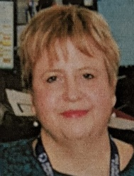

The Service was held by Stuart with Sue and Mary and Robin in the congregation. Social distancing had to be observed so unfortunately not all who wanted to attend the service could.
Stuart started the service with words of introduction and asked Claire to formally confirm her commitment to serve the 3 parishes. Claire confirmed her commitment and the Congregation formally confirmed it welcomed her.
Clare was commissioned by the presentation of symbols of her new ministry.

Sue held up a Bible and asked Claire to confirm she would proclaim the Word.
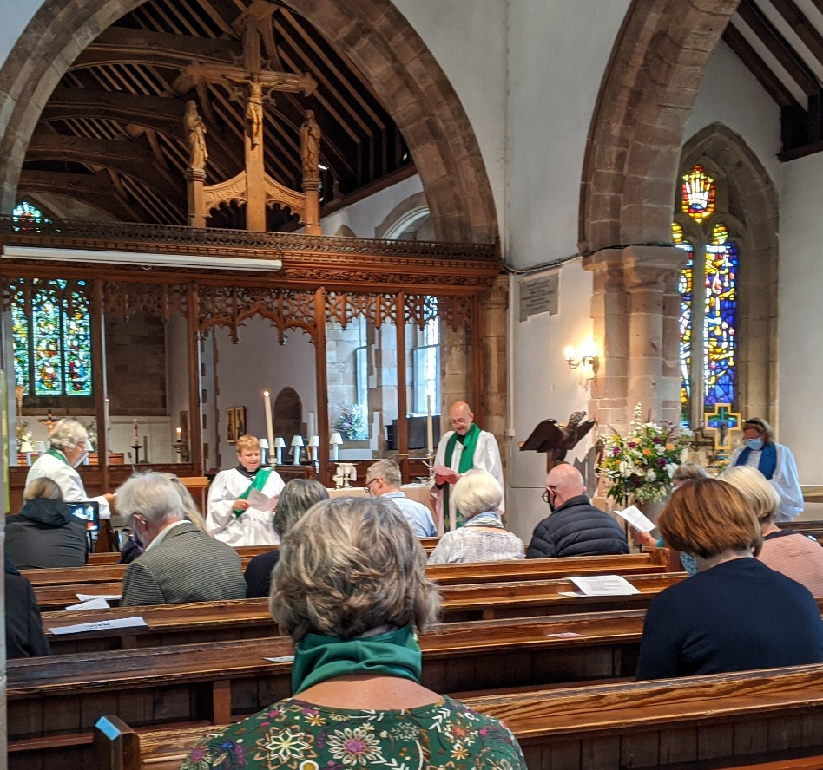

Mary held up a prayer book asking Claire to confirm she would be a minister of prayer.
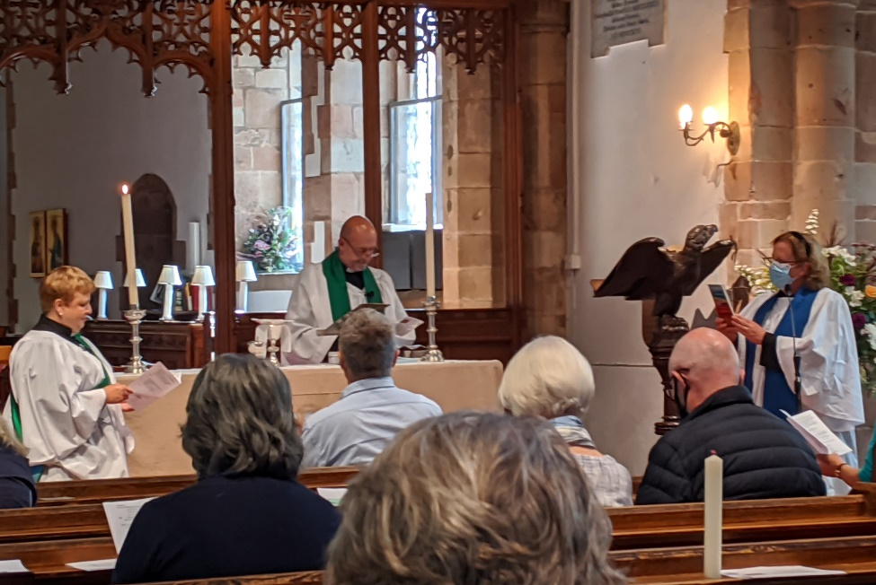

A member of the congregation from Barston held a jug of water asking Claire to draw people to the Living Water .
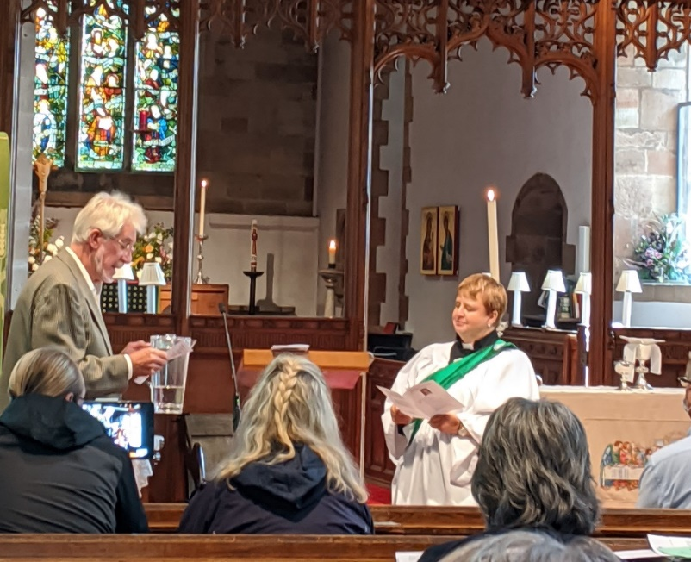

A member from Bickenhill held a lit candle asking Claire to be a minister among us and proclaim God’s shalom
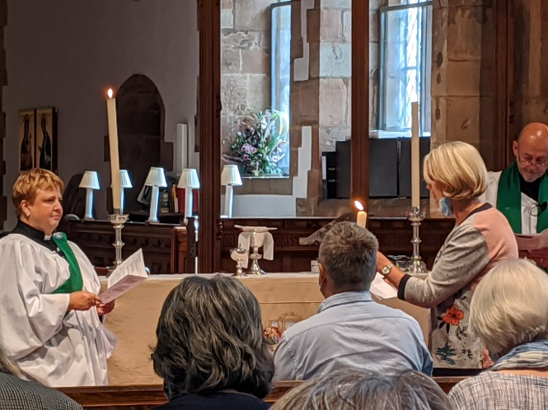

After the service Claire, together with her husband Mike, met the congregation as they left.
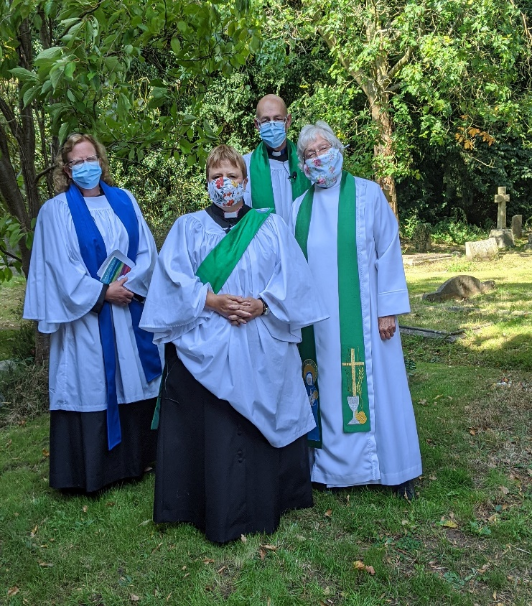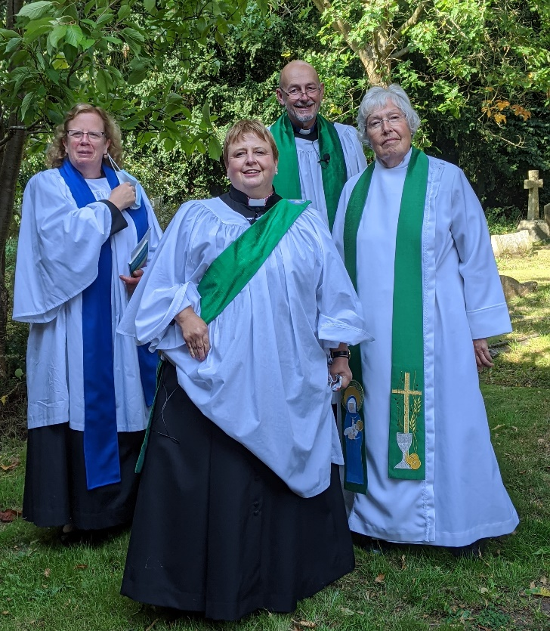
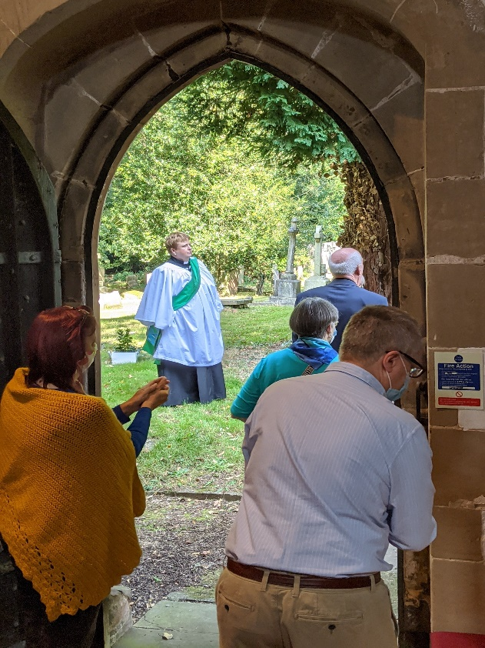

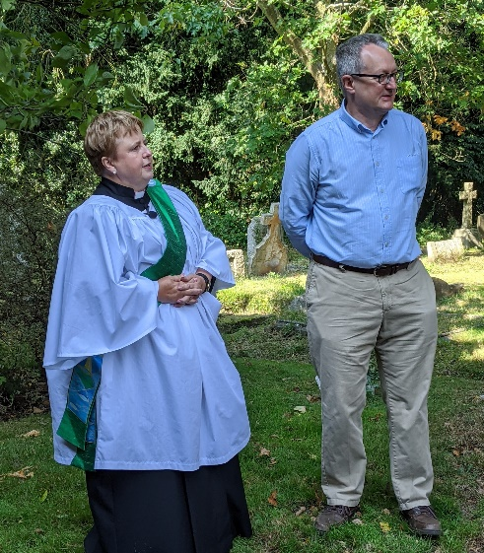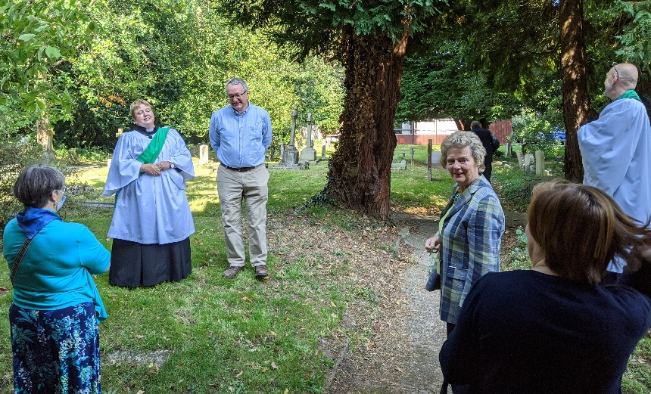

The service was broadcast on the internet thanks to the hard work and technical jiggery-pokery of Darren and Heather!
Kim supplied as always the music from the piano and the vocals; how does he do it ?

