Services for next week:
Hampton-in-Arden

Thursday 4th June
10am Communion

Sunday 7th June
8.15am Common Worship
11am All Age Service
6.30pm Healing Communion

Bickenhill

Sunday 7th June
11am Morning Prayer

Barston

Sunday 7th June
9.45 Prayer Time
10.30am All Age Service with Chris J Taylor.

Readings for next week:
Romans 4. 13-end; Matthew 9. 9-13, 18-26

We pray for: Judy Middleton, David Mort, Ann Hall, Tony Worthington, Mona Cardall, Dot Barton, Richard Herne, David Vickers, Vickey Cardwell, Chris Cluley and Barbara Waring. Paul Pilkington-Birch, Richard Mitchell, Roger Abrahams, Morris Dobbie, Doreen Morris, Robin Mortimore, Michelle Cluley, Keith Ward, Jenny Miller, Rick Smallwood, Graham Stidworthy, Gwen Eley, Jenny Miller and Margaret Thomas.
We also pray for the families of those who have died; David Moore, Pauline Booker, Anne Oliver-Jones, Angela Jones and Janet Griffiths. If you would like people to be prayed for do let us know office@hamptoninardenchurch.org.uk

Please recycle this pew slip.
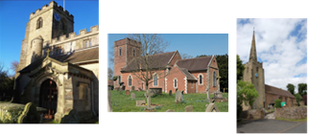

Hampton. Barston. Bickenhill.

Three Churches Together.

Sharing God’s Love, Growing Faith and Worshipping Together.

31st May 2026- Trinity Sunday
2 Corinthians 13.11-end; Matthew 28.16-end

Thought for the week
Stay or Go! Matthew 28 16-20
In most bibles, today’s gospel reading has the subheading, ‘The Great Commission’.
This heading tempts us into thinking that we already know what this scene is about.
This scene is Jesus’ sole resurrection appearance to the 11 disciples in Matthew’s
gospel. His appearance is met with awe, wonder, confusion and doubt. When they
saw Jesus, some worshipped while others doubted. Life had crumbled around them
as Jesus was arrested and crucified, they must have questioned everything they
thought they knew. Sounds familiar.
In that moment the mystery of God as Trinity is disclosed, Father, Son and Holy
Spirit is God. The disciples discover that they needed to flip their understanding of
what it means to be a follower of Jesus on its head. As the one who said, ‘follow me’,
now promises to be with them, eternally, as they go. That is, all of them, despite
their doubting or their wavering, including us today- so let’s go!
SD
Collect
Holy God,
faithful and unchanging:
enlarge our minds with the knowledge of your truth,
and draw us more deeply into the mystery of your love,
that we may truly worship you,
Father, Son and Holy Spirit,
one God, now and for ever.
Knowle Parish Church are hosting another Friday Night Girls’ Night on 5th June at 7pm, joined by Sahar Twesigye. Sahar co-leads St James Kidbrooke church with her husband, Andrew. Her experience of persecution for her faith has given her a deep passion to see the church strengthened by the Holy Spirit and living with courage. She is a passionate evangelist and loves calling people into bold, wholehearted faith in Jesus.

Hampton
- Today at 2pm we look forward to welcoming the family and friends of Klara and Gavin for their baptisms.
- We are all saddened to hear of the passing of Janet Griffiths this week. She was a long-time member of Hampton Church, former PCC member and Churchwarden. We pray that she may rest in peace.
- PCC meeting at 7.30pm this Tuesday 2nd June.
- Friday 5thJune-Tea and Toast Stay and Play at 9am in the church hall. Next JAM session on Sunday 7th June.
- Saturday June 13th Church Open Day 10am-2pm. Hampton History Society will have a display of village history, light refreshments available and all welcome.
- Hampton Village Festival Saturday 4th July and Open-Air service/ Big Lunch Sunday 5th July. We are collecting good quality books, jigsaws and soft toys so please leave in the back of church or let the office know if you need collection.

Barston
- Thank you to Jennifer for organising our missionary focussed Sunday today and for those contributing – Chris Cook and Anne Oughton, Chris T for playing, Vera for reading, Martin projecting and Ian for the audio.
- Tuesday 2nd June Hobby House from 10am and Tea Club from 2pm. Both in St Swithin’s House. All welcome.
- Wednesday 3rd June service at Eastcote Park at 11am. Church members involved.
- Friday 5th June Coffee Morning at Eastcote Park at 11am. All most welcome.
- Next Sunday 7th Family Lunch after the service. A time of fellowship and sharing a delicious meal together.
- The next Big Breakfast is Saturday 13th June. Put the date in your diary.
- Eco News. On Saturday June 6th Knowle Parish Church are hosting a GREEN FAIR in St John’s Hall from 10-12noon. It’s a way to find out more about simple environmental swaps and initiatives. Perhaps invite a friend along?
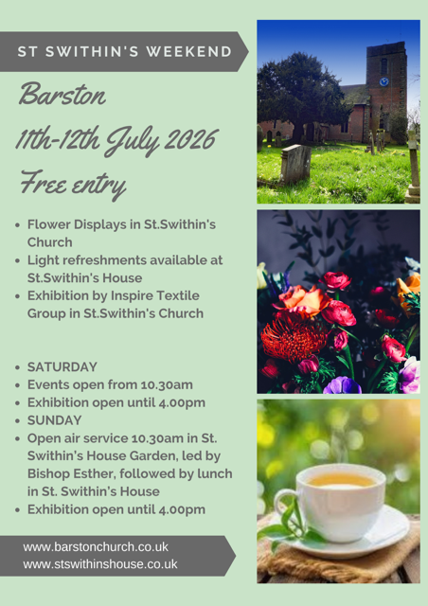

Bickenhill

- We shall be having a stall at the Hampton Village Festival, which is on 4th July. Please can you bring any items you no longer want or use. If you have a craft skill and would like to donate items to sell this would be very much appreciated.
- The work in the churchyard starts on 10th June; unfortunately a couple of trees need to be felled and several trees will be pollarded. Although we have someone to cut the grass it is getting increasingly difficult to keep on top of the weeds and keeping the graves tidy. If you would like to help please speak to the churchwardens or if you would like to make a donation to the churchyard fund then please get in touch.
- Next PCC meeting 26th July after the service.

